W10 Articulate
Polymorphism is the ability to change or mold a class in order to fit the needs of another class. This often is shown through base classes that have subclasses with very different needs, but similar results/objectives. This concept is very similar to inheritance in the way that it allows you to have one base class with shared attributes for different classes. It differs in the way that it changes the methods instead of the attributes. The method in the base class will likely be empty and ready to be written in. The subclasses will have the ability to override the empty method with its own method. This tailors the use of the method to the subclass being used and allows less lines of code and easy change/update without breaking the program. This was especially useful in the Goal tracker prove assignment where each subclass needed a unique way of recording an event or displaying the goal. The base method had the empty methods ready to be filled. The subclasses had written methods to override the base class.
Base class methods:
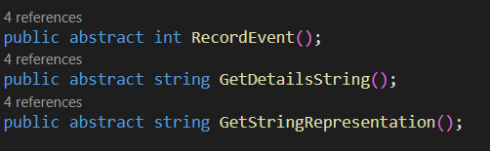
Subclass methods:
